**CI/CD**

**FINAL LAB EXPERIMENT**

**SUBMITTED BY:**

NITISH KUMAR SINGLA

500071913

R171218126

**SUBMITTED TO:**

HITESH KUMAR SHARMA SIR

**Create a Simple Maven project and create its Build using Jenkins Dashboard**

**Create a Maven Project and Create a Class in Eclipse**

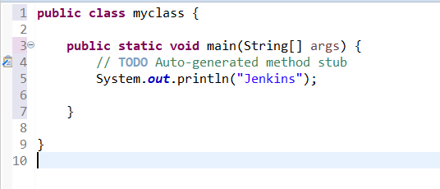

**Add required plugins and dependencies in Maven Project**

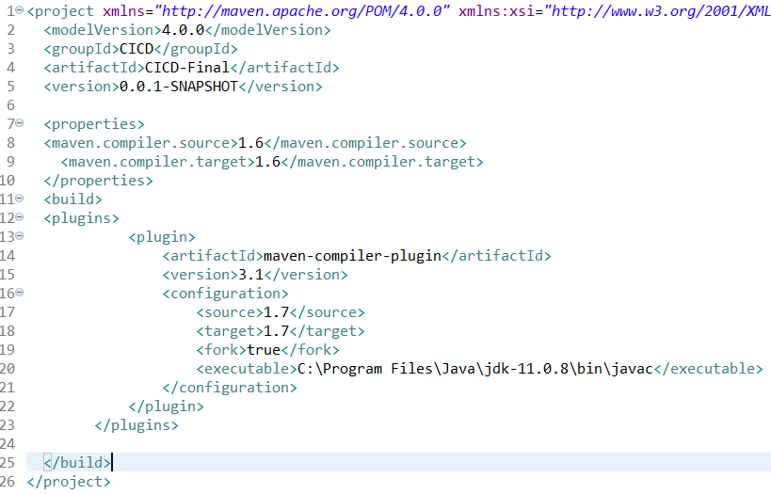

**Push the Maven Project to Github**

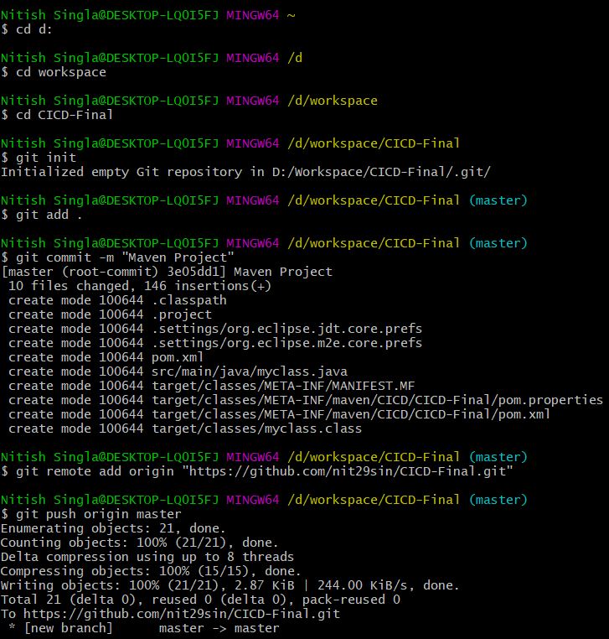

**Maven Project in Github**

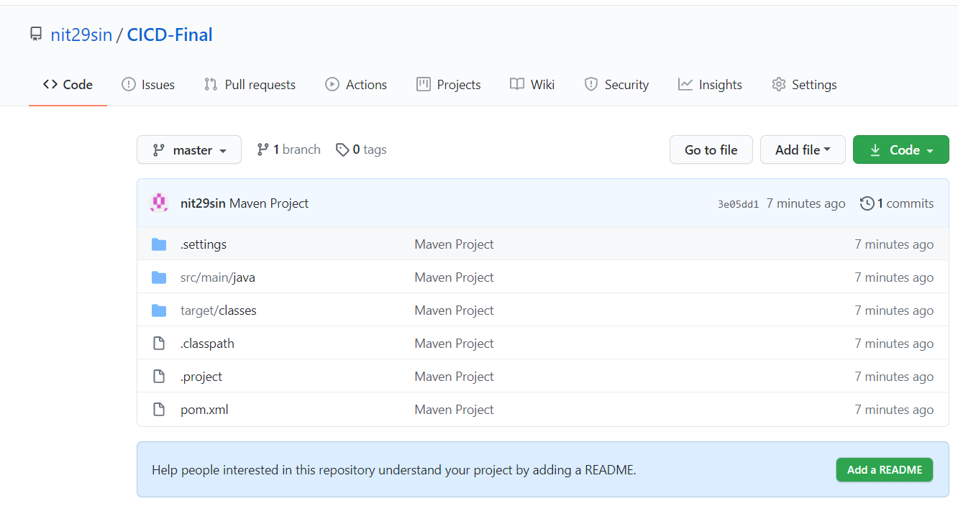

**Create a Maven Project in Jenkins**

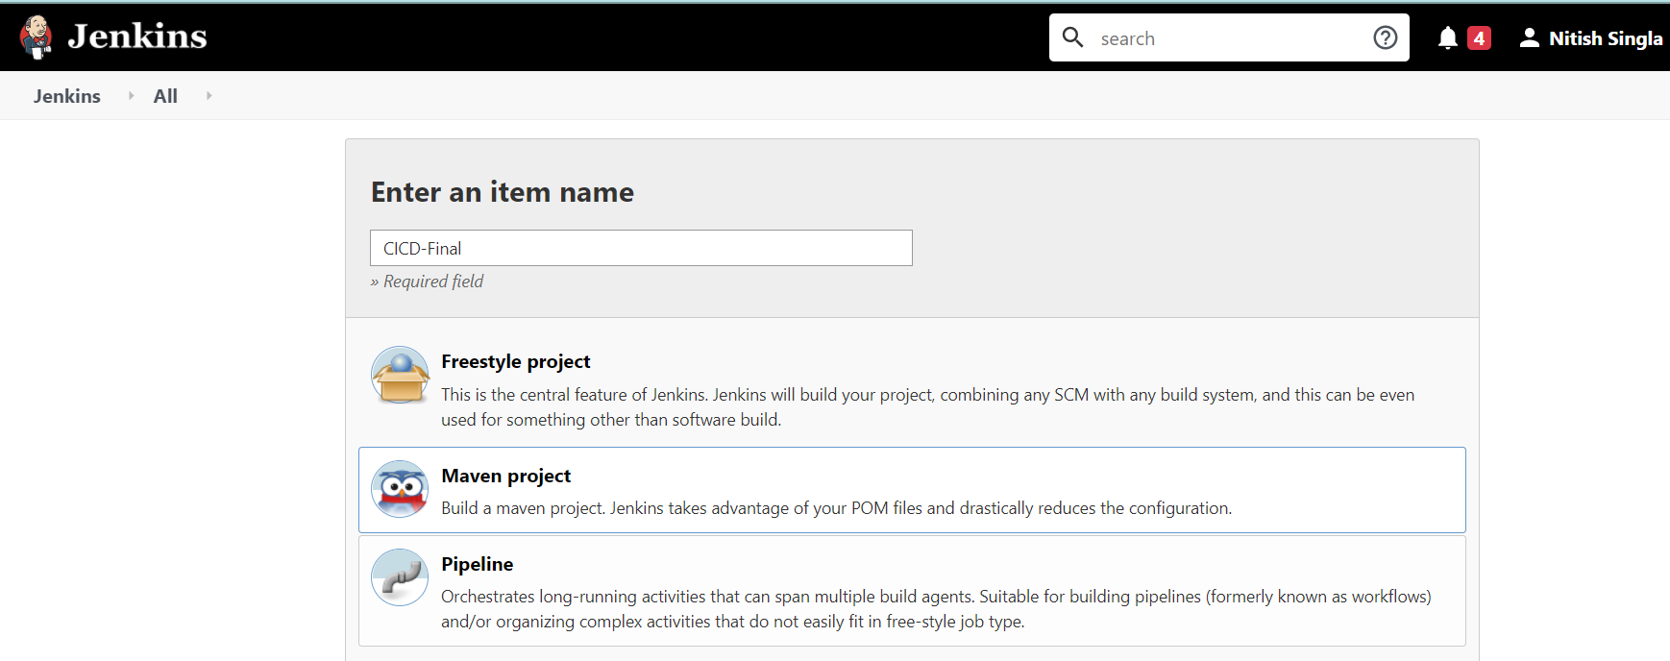

**Add Github URL which contains the Maven Project**

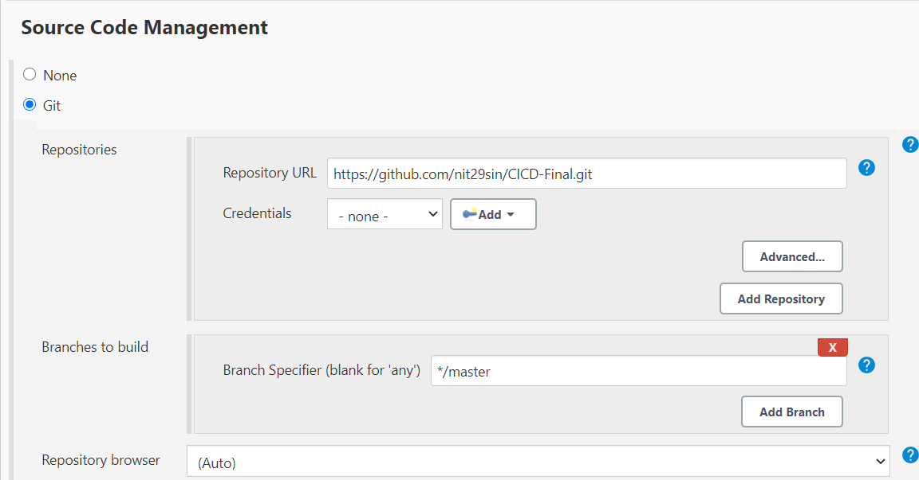

**Add Maven Command install to create build of the Maven Project**

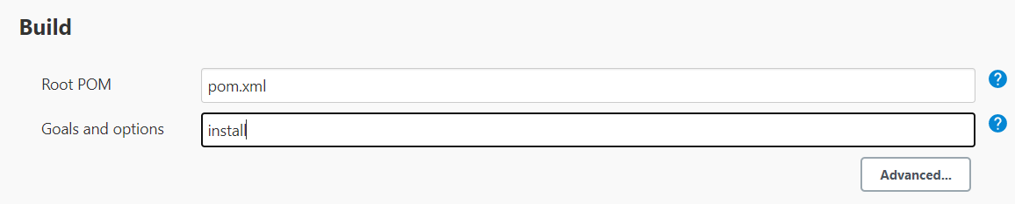

**Build Successful**

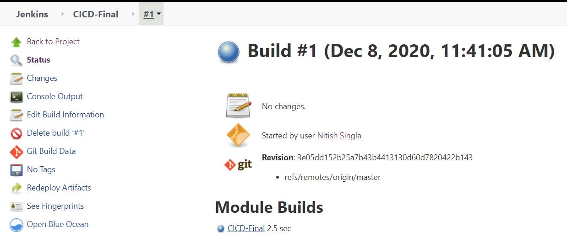

**In the console output, you can see build success**

